**Alcohol, Well-Being, and Arkansas’s Low Performance**

In this research paper I explore the effects of alcohol on happiness as defined by the Gallup-Healthways well-being index. In addition I will discuss the implications of dry counties, and compare my research with similar studies conducted at Oxford University. I chose this topic after discovering that my state, Arkansas, is ranked 46th out of 50 states in the 2016 well-being Index. The presence of dry counties came to my mind as something present in Arkansas that is not present in the top 10 happiest states. In fact Arkansas has the highest proportion of dry counties of any state in the U.S. 48% of counties in Arkansas are dry. With this in mind I constructed a model that would strive to show if there exists a relationship between state level well-being index and alcohol consumption. The later part of this paper will discuss what policy decisions Arkansas should make in order to obtain a higher well-being index score. Variables used in this model are as follows:

OVR_IN – 2016 Overall State Well-Being Index Score

PROP_DRY – The number of dry counties in a particular state divided by the number of total counties in that state. A dry county is defined as a county in which the sale of alcohol is prohibited. This data came from ____.com[1]

CONS_ALC – Alcohol consumption per capita from all beverages in the U.S. in 2016, by state (in gallons of ethanol) This data was provided by ____.com[2]

ACTIVE - The percentage of state residents who report having felt active and productive every day in the last seven days

WORRY_MONEY- The percentage of state residents who report having worried about money in the last seven days

COMM_INV- The percentage of state residents who report having received recognition for helping to improve their city or area in the past 12 months

PRODUCE- The percentage of state residents who report eating five or more servings of fruits and vegetables four or more days per

EXR- The percentage of state residents who report exercising for at least 30 minutes three or more days per week

UN_INSR- The percentage of state residents who say they do not have health insurance coverage. This variable data along with OVR_IN, ACTIVE, WORRY_MONEY, COMM_INV, PRODUCE and EXR came from Gallup.com. [3]

GDP_STATE- Gross domestic product (GDP) by state: All industry total (Millions of current dollars) This data was provided by the BEA[4]

I included the variables: CONS_ALC, ACTIVE, WORRY_MONEY, COMM_INV, PRODUCE, EXR, and UN_INSR because they are all factors that are related to the overall state well-being index as calculated by Gallup-Healthways. GDP_STATE was not a variable provided by Gallup-Healthways, but I felt as though this variable needed to be included to represent the role of the economy in the model. I then included the following variables in order to gauge the effect of alcohol on the state well-being index: PROP_DRY and CONS_ALC.

After creating a correlation matrix for all dependent variables used in the model we can see the only variables that show correlation are: COMM_INV and ACTIVE, EXR and ACTIVE, COMM_INV and EXR, and PRODUCE and EXR.

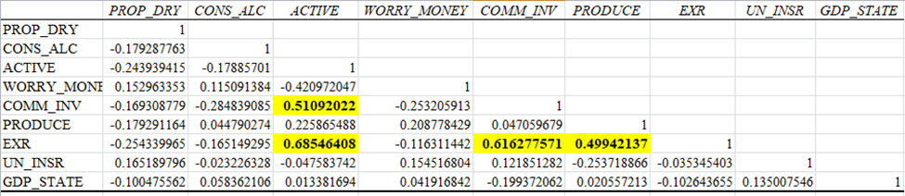

All 4 of these relationships intuitively make since. Essentially, the more active a person is the more likely he or she is to be involved in the community or exercise. The more a person exercises, the likely hood of that person being involved in the community or eating produce increases. While these variables shared a correlations of .4999 or more no two variables had a correlation that was extremely high. Thus I kept the variables, ACTIVE, COMM_INV, PRODUCE, and EXR in the first model such that:

$\hat{OVR_IN}=\hat{β_{0}}+\hat{β_{1}}CON_ALC+\hat{β_{2}}ACTIVE+ \hat{β_{3}}WORRY_MONEY+ \hat{β_{4}}COMM_INV+ \hat{β_{5}}PRODUCE+ \hat{β_{6}}EXR+\hat{β_{7}}UN_INSR+ \hat{β_{8}}GDP_STATE$

Running a multiple linear regression with this model yielded the following results:

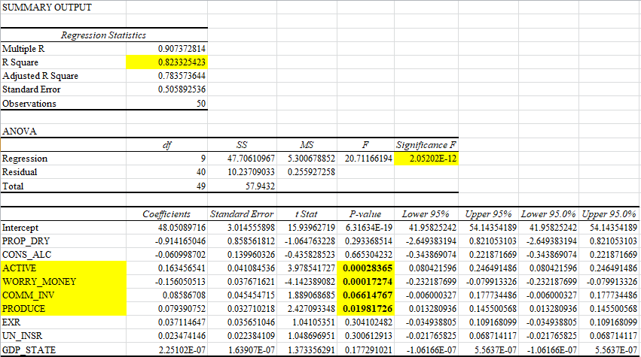

To my surprise the variables PROP_DRY and CONS_ALC were not statistically significant. However when taken as a set, the variables included in this model yield an R squared of .823, meaning that 82.3% of the variance in OVR_IN can be explained by the depended variables. The variables ACTIVE, WORRY_MONEY, and PRODUCE are statistically significant at the 0.05% level. COMM_INV is also statistically significant, however it just misses the 0.05% level. The variable ACTIVE certainly makes since in this model. ACTIVE is defined as the percentage of state residents who report having felt active and productive every day in the last seven days. If a state resident has not felt productive in the last seven days then he/she is more likely to be less happy or have a higher well-being index score. Arkansas for example has a ACTIVE percentage of 66% versus 71% in it-’s neighboring state Texas which is ranked 11th in terms of the well-being index. From this model we can see that with an increased percentage in ACTIVE, the OVR_IN Increases by 0.1634 points. WORRY_MONEY another statistically significant variable intuitively makes since. With an increased percentage in WORRY_MONEY, the OVR_IN decreases by 0.156. This means that the more a state’s residence are worry about money the less likely they are to be happy. The percentage of Arkansas residence that worried about money in 2016 was 36.6%, or 2.18% above the nationwide mean of 34.42%. This also can explain why Arkansas has a low well-being index score.

While the first model showed us that the variables ACTIVE, WORRY_MONEY, COMM_INV, and PRODUCE are statistically significant, the first model did little to explain the role of dry counties on the well-being index. We found from the last model that neither PROP_DRY nor ALC_CONS were statistically significant. However it is possible that the PROP_DRY is reflective of cultural values in a state. Of the states that have dry counties: Arkansas, Florida, Georgia, Kansas, Kentucky, Mississippi, South Dakota, Tennessee, and Texas, only two, Florida and Kansas are located outside of what is known as the Bible Belt.

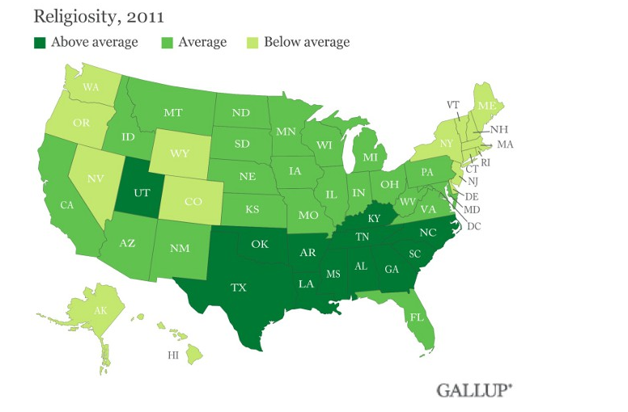[5]

States in the Bible Belt are those who have a higher reported religiosity rating than other states. With this in mind I created a new model to see if states who have a higher religious rating are more or less happy. Also in the model I included a variable measuring the percentage of residence who identify as republican. In doing this I tried to capture the profile of residents who would be in favor of having dry counties. Originally I had included statistics for percent of residents who are conservative and percent of residents who approve of President Trump, but both of these variables were too highly correlated with either religion or republican.

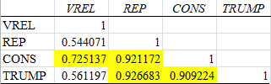

Thus the variables added to the second model are:

VREL- The percentage of state residents who say religion is important in their lives and say they attend religious services weekly or nearly weekly

REP- The percentage of state residents who identify as republican both of these variables came from Gallup.com [6]

The final model and regression results are as follows:

$\hat{OVR_IN}=\hat{β_{0}}+\hat{β_{1}}CONS_ALC+\hat{β_{2}}ACTIVE+ \hat{β_{3}}WORRY_MONEY+ \hat{β_{4}}COMM_INV+ \hat{β_{5}}PRODUCE+ \hat{β_{6}}EXR+\hat{β_{7}}UN_ISN+ \hat{β_{8}}GDP_STATE+ \hat{β_{9}}VREL+\hat{β_{10}}REP$

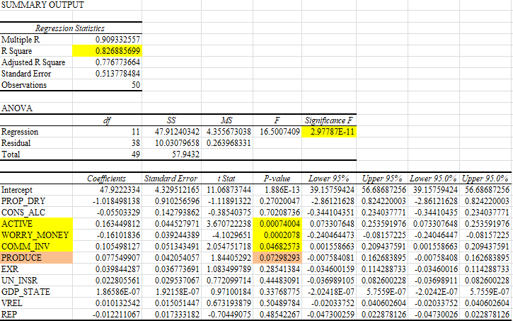

We can see from these multiple linear regression results that VREL and REP are not statistically significant variables. Thus we can conclude that VREL and REP have no affect one a state’s happiness level and neither does PROP_DRY or CONS_ALC. Not only does a state’s decision to have dry counties not have an effect on the well-being index of a state, but also a state having a higher percentage of citizens who would be in favor of dry-counties, in this model religious and republican, have no effect on the well-being index of a state. Using the White Test we can see that the Prob > chi2 is not < 0.05 therefore we cannot reject the null hypothesis for homoscedasticity.

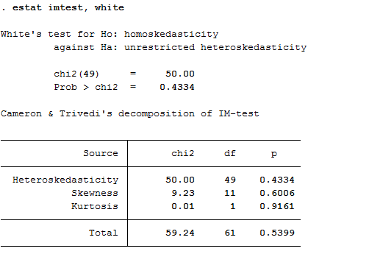

Through the last regression model another question arose. While a state having a higher proportion of dry counties is not necessarily less well-off according to the well-being index, does the policy decision to enforce dry counties have an effect on the level of alcohol consumption? Without running a regression below I show the mean alcohol consumption (ALC_CONS) for all states and the alcohol consumption (ALC_CONS) for states with dry counties.

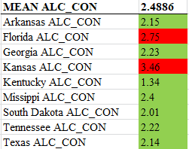

It appears that only 2 of the 9 states which have dry counties have an above average alcohol consumption per capita than the U.S. mean alcohol consumption per capita. From this analysis it appears that the policy decision to enforce dry counties may be effective. Of course to truly test this hypothesis an entirely new model would need to be created that included all factors that could influence alcohol consumption, because it is possible that the religiousness of these states could affect the consumption of alcohol more so than the policy decision itself. In any case we can see that on average, with the exceptions of two states, the alcohol consumption in states with dry counties are less than the U.S. mean. To further analyze the states with dry counties, listed below are the OVR_IN for each state that has a dry county compared with the Mean OVR_IN. From this we can see that 4 of the states with dry counties are above the MEAN OVR_IN and 5 states are below the MEAN OVR_IN. Additionally only 2 states are outside of the MEAN OVR_IN by 1 standard deviation.

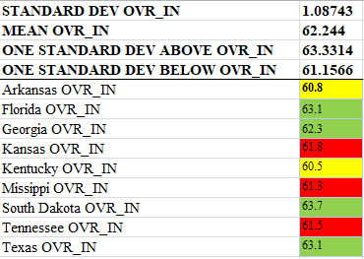

South Dakota is the only state with dry counties that is one standard deviation above the MEAN OVR_IN with Texas falling not too far behind. This analysis aligns with our previous models showing that the presence of dry counties have no effect on the overall well-being of a state.

A portion of the inspiration for this research came from a study done completed at the Department of Experimental Psychology at University of Oxford by Professor Robin Dunbar. This research paper concluded that visiting a pub on a regular basis is beneficial for one’s health. This conclusion is not reached because alcohol is good for one’s health, but rather because social interaction with others is beneficial. Through surveying techniques the research team at Oxford found that, “those who had a ‘local’ reported that they were significantly more connected to their community than those who did not”[7] This is particularly interesting because from the multiple linear regression analysis COMM_INV proved to be a statistically significant variable in terms of its effects on OVR_IN. From this line of reasoning we would think if more state residence had a “local” (bar/pub) then COMM_INV would rise at the same time alcohol consumption would be higher making ALC_CON a statistically significant variable in the multiple linear regression models. However this is not the case. In the study 32% of UK residence reported a pub to be the best place to socialize with friends.

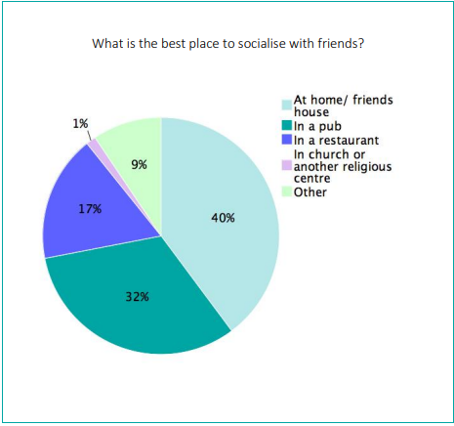

Shockingly only 1% of U.K. residence in the survey reported a church or religious center to be the best place to socialize with friends. This is not likely to be true for U.S. residence. Data from Gallup’s state of the state’s report shows us that 37.16% of U.S. residence surveyed says that religion is important in their lives and says they attend religious services weekly or nearly weekly.[8] This could explain why alcohol consumption has no statistical significance in the U.S. Our residence gain valuable social interaction in religious settings rather than in a pub or elsewhere. From the Oxford study which predicted a patients likelihood of surviving a heat attack showed that “The quality of a patient’s social networks (how well embedded they were within their network, how supportive their friends and family were) had the biggest effect on likelihood of surviving.” [9] This further explains how important the implications of community involvement are on the well-being of residence. While the U.K. may have a culture of gathering in pubs and the U.S. a culture of gathering at church the important factor in well-being is the face to face interaction with others.

Overall we can conclude that U.S. States whose residence are more involved in their communities and live a healthy lifestyle are more likely to achieve a higher score on the well-being index. While Arkansas has an unusually large proportion of dry counties, this is not the explanation for its low well-being index score. If Arkansas wants to achieve a higher well-being index score for its residence it should focus on promoting healthy living including proper diet and exercise for its residence. Additionally, Arkansas should focus on community engagement in any form possible. My analysis has shown that states where residences more often receive recognition for improving their community are more likely to receive a higher well- being index score. Additionally, Arkansas should focus on creating higher paying jobs and financial wellness programs in order to reduce the number of residence who worries about money, another statistically significant variable.

**Works Cited**

CityLab, and University of Toronto’s School of Cities and Rotman School of Management. "The Real Boundaries of the Bible Belt." CityLab. April 04, 2013. Accessed December 01, 2018. https://www.citylab.com/equity/2012/03/real-boundaries-bible-belt/1617/.

Dunbar, Robin. *Friends on Tap*. University of Oxford. CAMRA. January 2016. Accessed November 2018. http://www.camra.org.uk/documents/10180/361237/FACTS ON TAP - A Report for CAMRA.pdf/f3f22bbc-8596-41b8-8d91-1906a80329a0

Gallup, Inc. "State of the States." Gallup.com. Accessed December 01, 2018. <https://news.gallup.com/poll/125066/State-States.aspx>

NABCA. "Dry and Wet Counties." Accessed November 2018. [https://www.nabca.org/assets/Docs/Research/White Papers/WetDry Counties.pdf](https://www.nabca.org/assets/Docs/Research/White%20Papers/WetDry%20Counties.pdf).

"Total Alcohol Consumption per Capita by U.S. State 2016 | Statistic." Statista. Accessed December 01, 2018. https://www.statista.com/statistics/442848/per-capita-alcohol-consumption-of-all-beverages-in-the-us-by-state/.

"U.S. Bureau of Economic Analysis (BEA)." U.S. Bureau of Economic Analysis (BEA). Accessed December 01, 2018. <https://www.bea.gov/>.

1. NABCA. "Dry and Wet Counties."
2. "Total Alcohol Consumption per Capita by U.S. State 2016 | Statistic."
3. Gallup, Inc. "State of the States."
4. "U.S. Bureau of Economic Analysis (BEA)."
5. CityLab, and University of Toronto’s School of Cities and Rotman School of Management
6. Gallup, Inc. "State of the States."
7. Dunbar, Robin. Friends on Tap. University of Oxford. CAMRA
8. Gallup, Inc. "State of the States."
9. Dunbar, Robin. Friends on Tap. University of Oxford. CAMRA